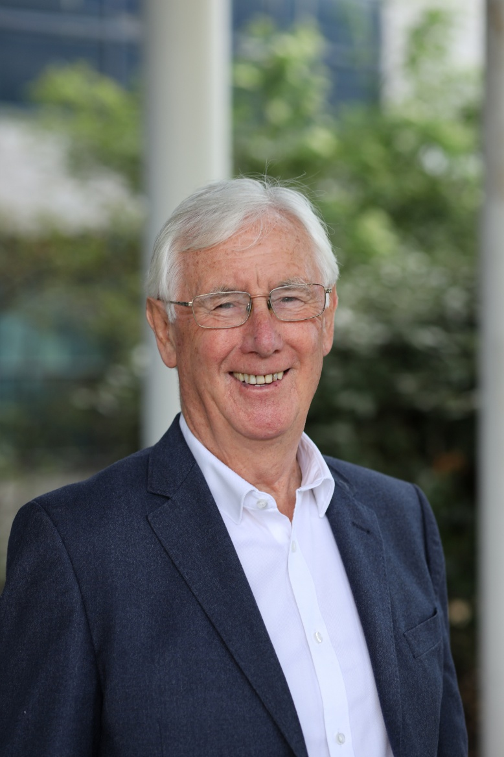
Les Walton CBE has been entrusted by successive governments to help shape national education policy, establish major national agencies and lead significant education system reform. That contribution continues through his work across the UK and internationally, including his recent appointment to His Majesty’s Inspectorate of Education (HMIE) Advisory Council in Scotland. Across more than six decades, his career has combined successful institutional leadership with sustained influence on the development of education systems.
Beginning as a history teacher, Les became Headteacher of Norham Community Technology College, identified by HMI as one of the country’s most successful urban schools. As Director of Education at North Tyneside, he led an authority that achieved Beacon Status for tackling school failure, with all its schools judged successful by Ofsted. He subsequently led the merger that created Tyne Metropolitan College, described as exemplary by the Department for Education, and has been called upon to support major organisational change and intervention in education authorities and institutions experiencing significant challenges.
Les has exercised significant influence on national education policy under different administrations. He was invited to No. 10 to advise Prime Minister John Major on the development of the new national inspection arrangements and subsequently contributed to education initiatives during the Blair Government. Secretary of State Ed Balls appointed him to establish and chair the Young People’s Learning Agency. Following the change of government, Secretary of State Michael Gove asked him to support the establishment of the Education Funding Agency and chair its Advisory Group. These appointments gave Les extensive experience of translating national policy into effective structures, governance and delivery.
He has also been an institution-builder, founding or helping to establish Schools NorthEast, Northern Education Trust, Northern Education Associates and the Association of Education Advisers(AoEA).
Les’s international engagement spans more than three decades. He chaired the Sarajevo Education Conference, bringing together education leaders from Eastern Europe, Russia, Central Asia and the former Yugoslavia at a critical period of reconstruction following the Balkans War. More recently, he was invited to speak at the National Conference on School Leadership in Nashville, Tennessee, which brought together more than 4,000 school leaders. Les also undertook a UK-wide tour with Professor Andy Hargreaves, speaking in Belfast, Glasgow, Cardiff and London.
Today, his international work focuses increasingly on how education systems develop leadership capacity, professional standards, collaboration and sustainable improvement, and on sharing learning across different national systems. He continues to regularly contribute to various education publications, including the AoEA Education Adviser book series. His books include ‘Education the Rock&Roll Years’ and ‘The Chronicles of a Time Travelling Teacher’. His new book ‘ The Secret Classroom’ is due to be published in 2027.
As Chair of the Association of Education Advisers and Visiting Professor at the University of Sunderland, Les continues to work with governments, education authorities and system leaders across and beyond the UK. His current work focuses particularly on system coherence, system leadership, professional standards, organisational capacity and the role of those who support, challenge and enable educational improvement.
Les was awarded an OBE in 1996 and a CBE in 2013 for services to education and has received an Honorary Doctorate of Education in recognition of his contribution to the profession

